|  |
| --- |
| Mobile Student Lookup  Milestone 5 Hand-In Document  11/8/2011  Brandon Knight, Mark Vitale, Ann Say, Katie Greenwald |

Contents

Executive Summary 3

Introduction 3

Project Background 3

Usability Report 3

Interaction Architecture 4

Initial Interface Design 19

Revised Interface Design 19

Index 25

Glossary 26

References 27

# Executive Summary

A useable prototype was developed for the Mobile Student Lookup application as a vector PDF. This prototype was tested with various users, who compared this proposed interface against the current web system. After reviewing user feedback, we made changes to the interface that would address these issues. We also wrote up the Interaction Architecture, which describes the different types of screens the user will encore while using the application.

Introduction  
We have done extensive design to our prototype, through gathering requirements, designing the interface to best suit the iPhone environment, and determining all the various use cases the user can be in during use of the application. But even with this, the prototype is hardly useful until others have tested it and tried out the features; even though the developers may think it is easy to use, that decision lies ultimately with the user. Before testing could be done on the users, various paperwork had to be created, including Consult Forms, Pre-test and Post-test Questionnaires, and Test Procedures. Once these were made, users from various demographics were chosen to test the two systems – the currently used web system, and our iPhone application. The test participants were students ranging from freshman up to graduate students, and included males and females, and people familiar and unfamiliar with the iPhone. Each test participant was given the same briefing before, during, and after the testing. Using the results from the usability tests, a revised version of the interface was designed to be more user-friendly and easier to use.

# Project Background

The Mobile Student Lookup Application is a mobile application developed for the iPhone, iPod Touch, and iPad hardware systems. Our clients for this project are Tim Ekl and Eric Stokes, both of which are Rose-Hulman Graduates. Features in this application were determined from the current web system in place, and will not lose any functionality from the functions of the current system, but will not include the class scheduling system. These features include: searching for a student's schedule by username, searching by room number, searching by class number, and overlaying schedules. The application needs to be user friendly, intuitive, and act as an improvement over using the current system on any of our application's supported platforms.

# Usability Report

The usability report is stored as an HTML file on the computer located in the usability lab.

# Interaction Architecture

The interaction architecture plan is on the following pages. As these interface architecture drawings are being inserted into this document from a standalone document, conflicting page numbers will exist on these pages. To find a page pertaining to the entire document, look for the page number below the footer bar. For the page numbers referred to by the actual interaction architecture drawings, look at the page number above the footer bar, as those numbers are local to the actual interaction architecture document.

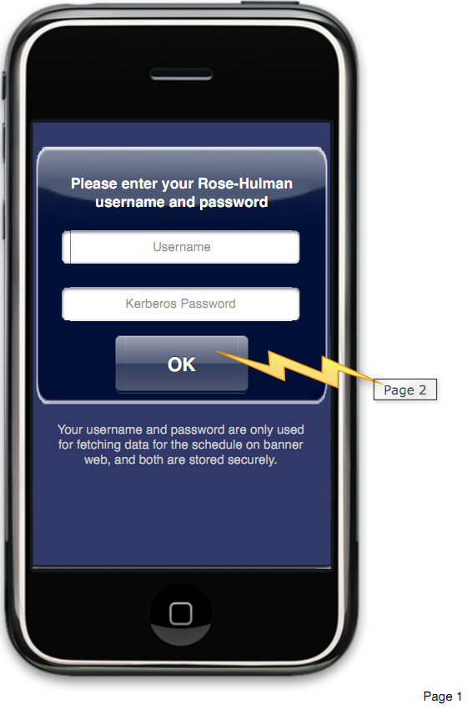 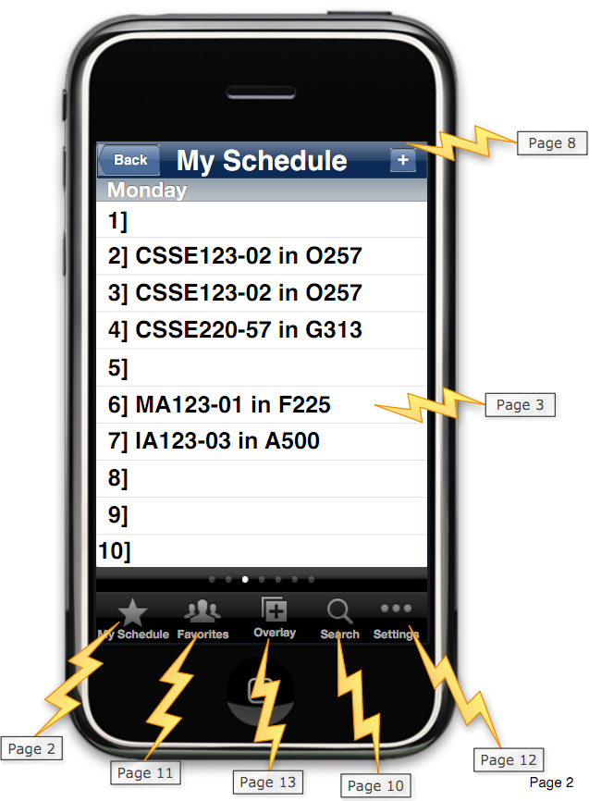 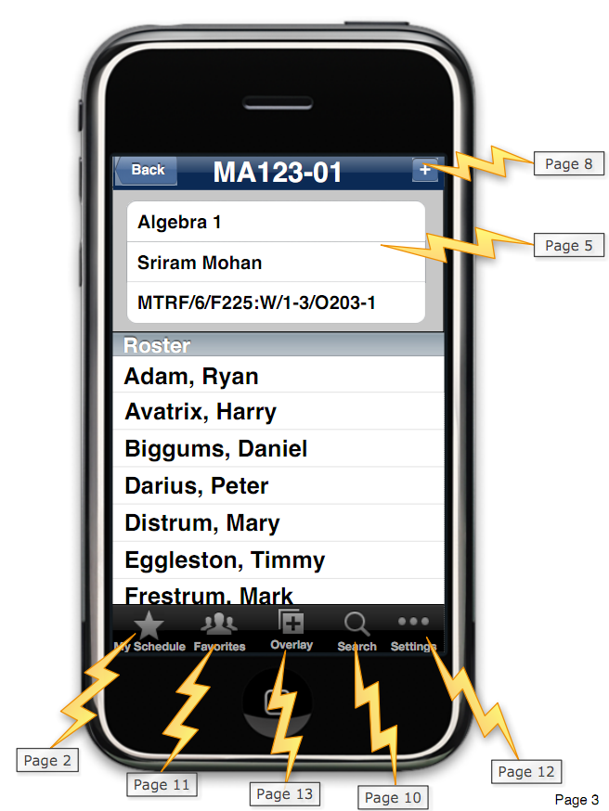 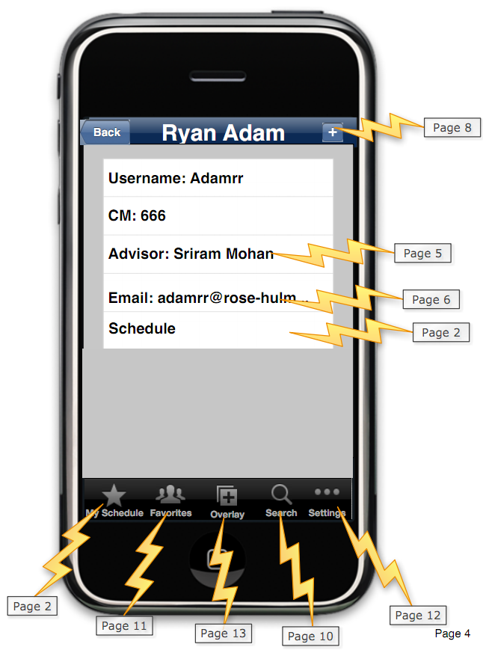 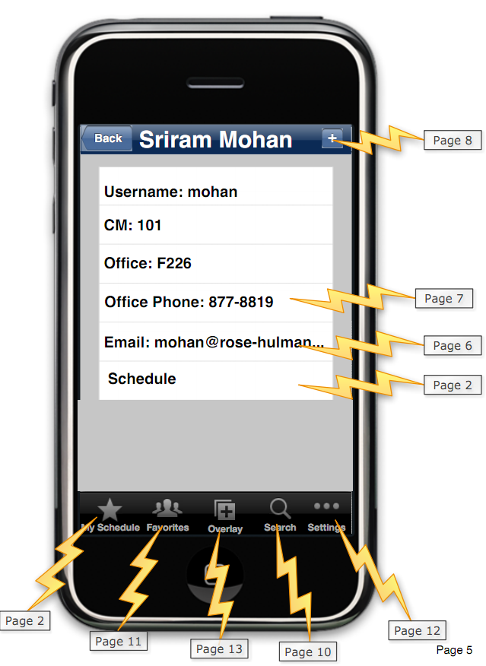 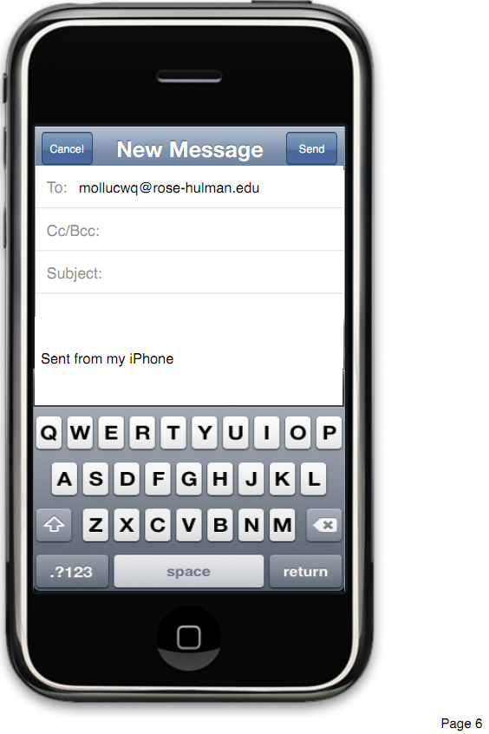 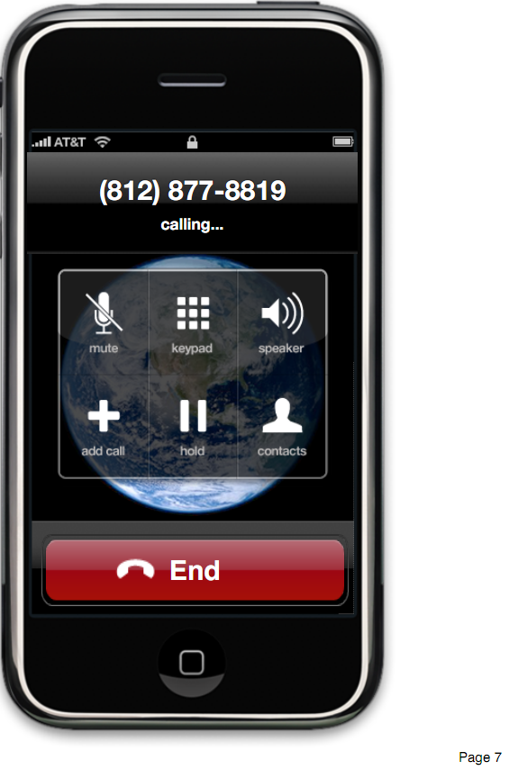 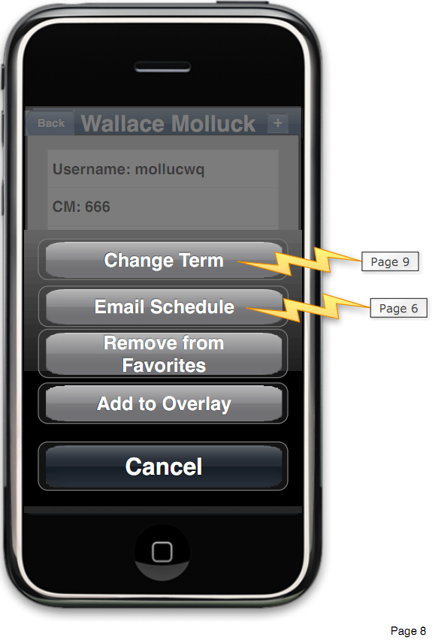 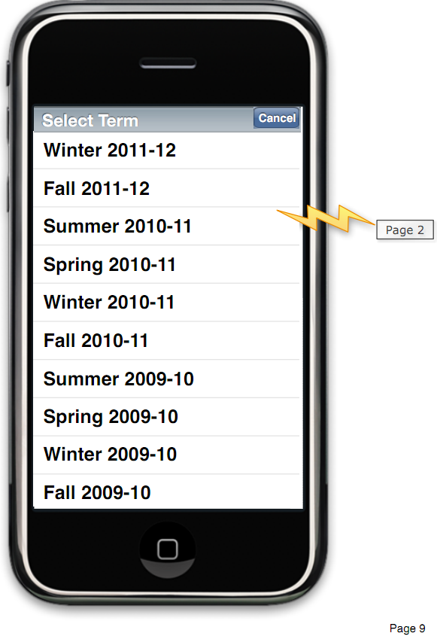 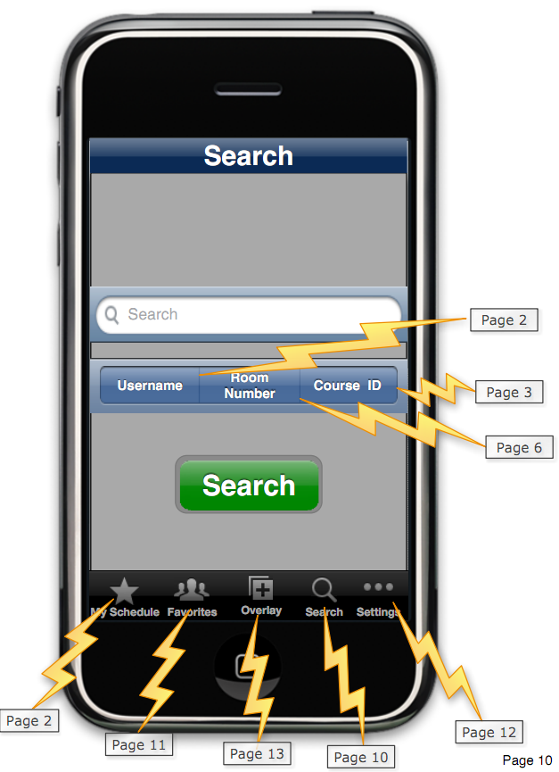 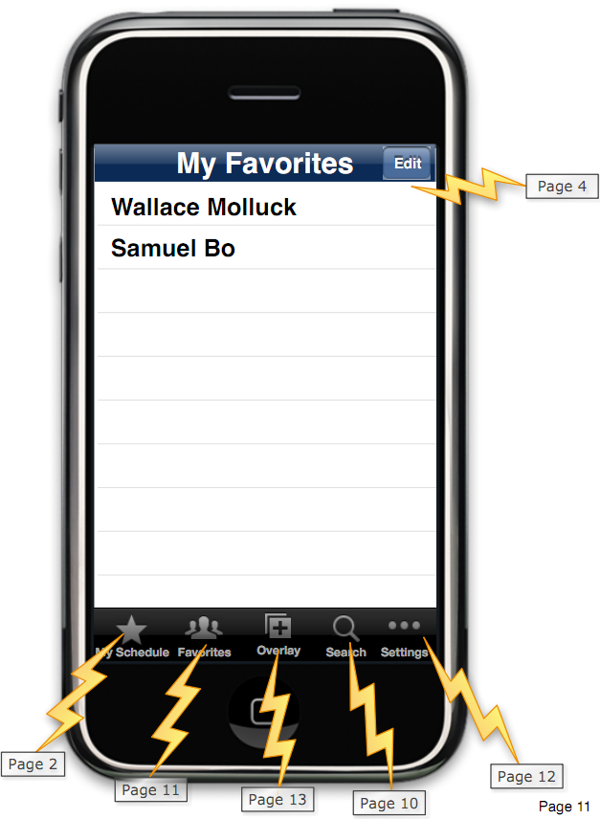 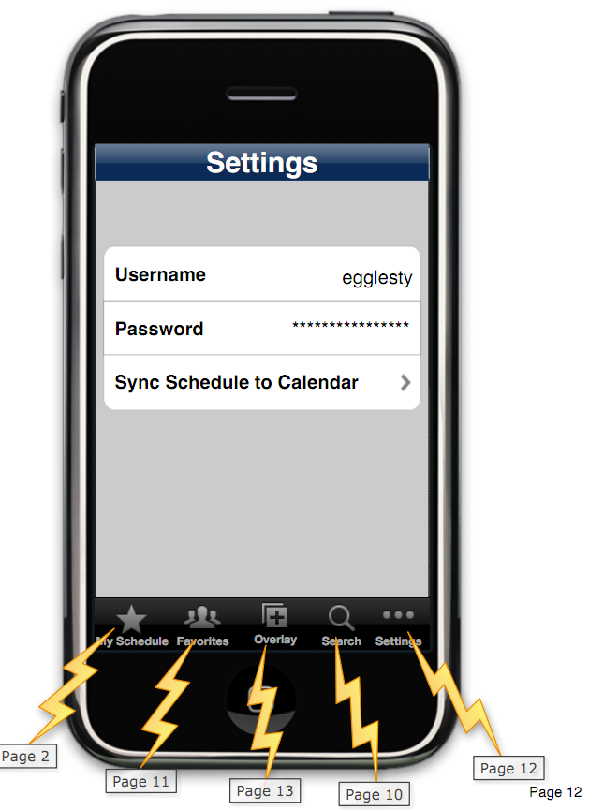 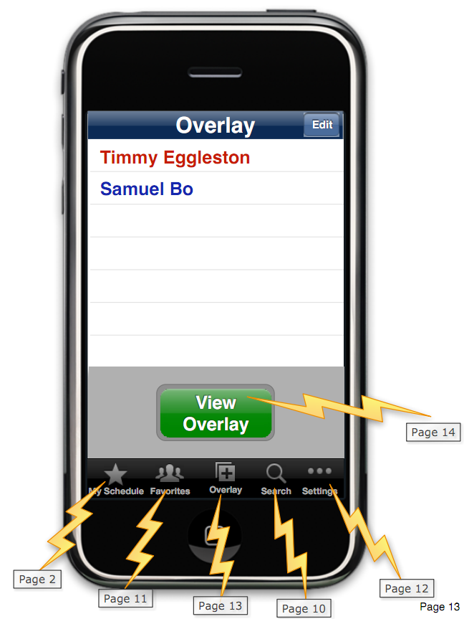 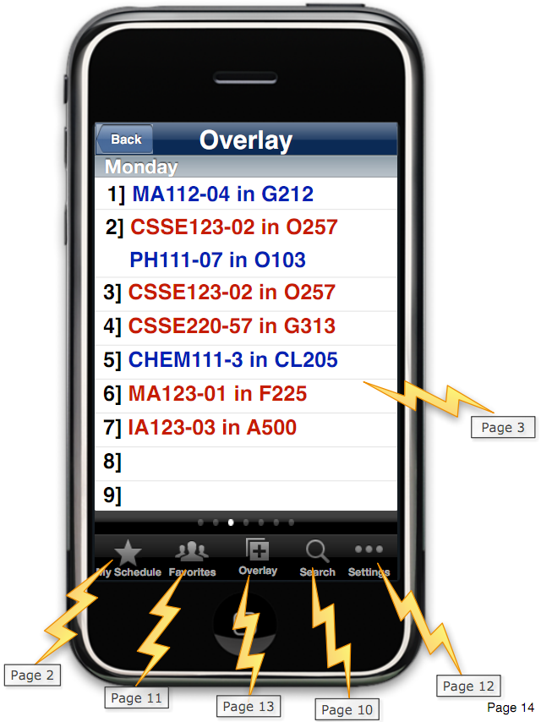

# Initial Interface Design

The initial interface design was submitted via e-mail as it is an extremely large vector PDF and the interactive functionality is not present in paper form.

# Revised Interface Design

As a result of the usability study, a few changes were made to accommodate for common issues faced by users. First, the term “Overlay” was confusing for many users who didn’t know what functionality to expect from that feature. Based on the responses of several usability study participants, the term was changed to “Compare.”

Secondly, in iOS apps, the expected functionality when a user selects the ‘+’ button is for something new to be created, not for an options menu to appear. To fit in more with the operating system, the ‘+’ button has been replaced with a “More” button to indicate that pressing that button may reveal more functionality.

Due to the issues with the previous overlay page, as few users actually discovered what it could do, the “Edit” button was replaced with a “More” button. Deleting items from the list is now performed with the “swipe to delete” gesture. On the “More” menu, the new options are to add yourself to the comparison, view the comparison for a term other than the current term, and view a help page that better describes the functionality of the comparison feature.

Finally, a few buttons were left active even when there was no effect due to the current state of the application. To help prevent users from being confused, all buttons are now grayed out when not active.

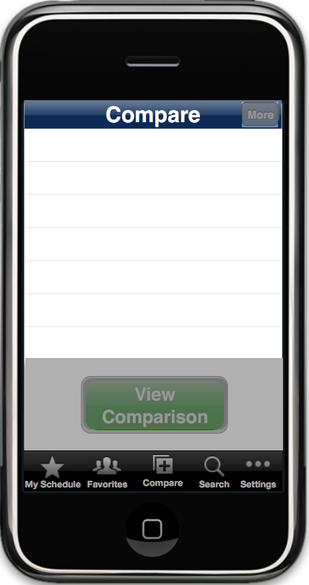This screen indicates that the overlay page has been changed to a Compare page. The tab has been updated accordingly. As neither button will do anything in an empty comparison, both buttons are grayed out.

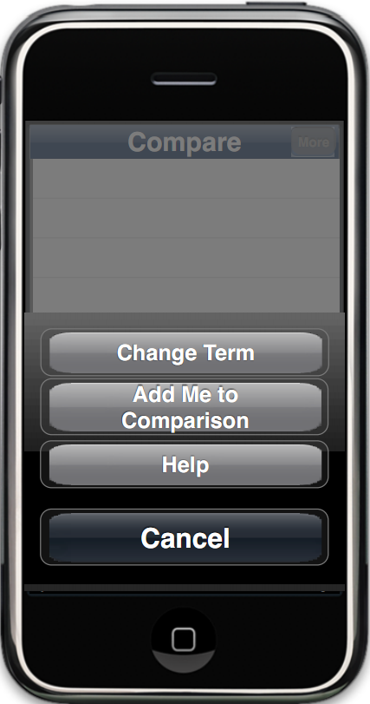The new “More” page for the comparison page. This includes adding yourself to the comparison, viewing a help page, and changing the term for the current comparison.

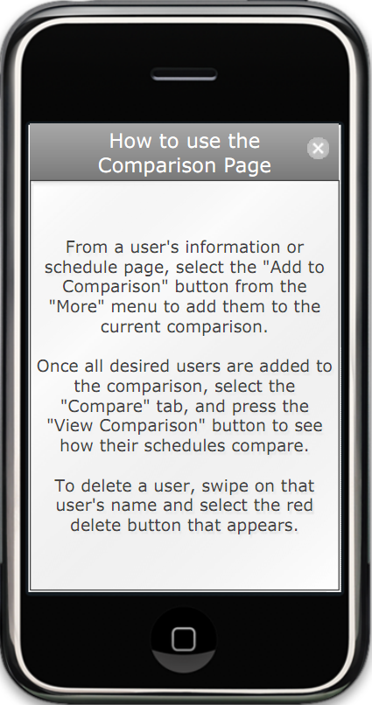The help page for the comparison page.

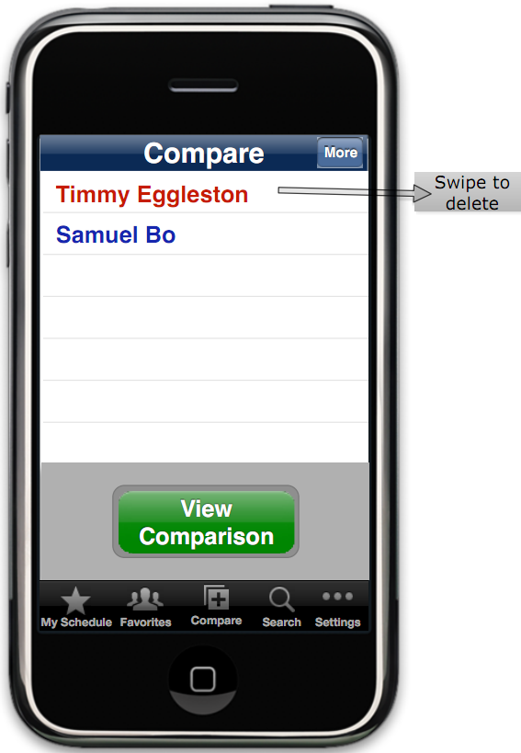Users are now removed using “swipe to delete.” Notice that the buttons are no longer grayed out due to the active users in the comparison.

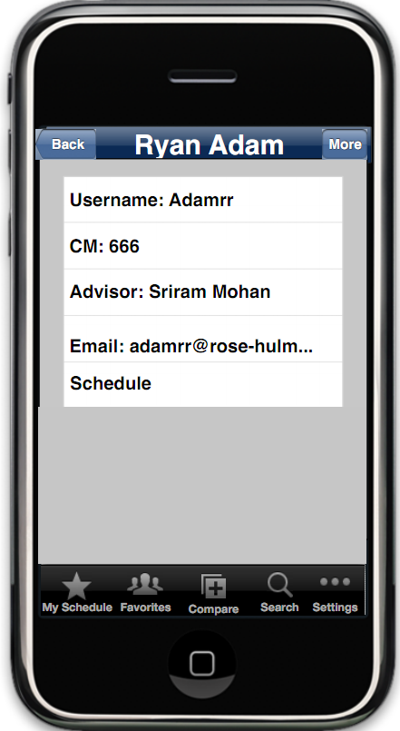

The new user info page has “More” instead of “+” in the top right corner. Compare has replaced Overlay in the tab bar.

# Index

features, 2

interaction architecture, 3

overlay, 18, 19

Rose-Hulman, 25

usability, 2, 18

# Glossary

|  |  |
| --- | --- |
| iOS | The mobile operating system developed by Apple that runs on iPhone, iPod Touch, and iPad devices |
| Rose-Hulman | The number one undergraduate engineering school in the nation, and the school at which the schedule lookup app will be used |
| Usability Study | A study to determine ease of use of a software application. |

# References

*iOS Developer Library Human Interface Guidelines.* (2011). Retrieved from Apple: Apple Inc. (2011) Human Interface Guidelines https://developer.apple.com/library/ios/#documentation/UserExperience/Conceptual/MobileHIG/Introduction/Introduction.html

(2011). iPhone Mobile Lookup Survey. (K. Greenwald, Interviewer)

*Schedule Lookup*. (2011, 4). Retrieved 10 18, 2011, from www.rose-hulman.edu: https://prodweb.rose-hulman.edu/regweb-cgi/reg-sched.pl

Apple Inc. (2011). *iOS 5 for Developers*. Retrieved October 11, 2011, from www.apple.com: http://developer.apple.com/technologies/ios5/

Apple Inc. (2010, 5 5). *Coding Guidlines.PDF.* Retrieved 10 26, 2011, from iOS Developer Library: http://developer.apple.com/library/ios/#documentation/Cocoa/Conceptual/CodingGuidelines/CodingGuidelines.pdf

Ekl, T., & Stokes, E. (2011, 9 21). Client Meeting. (M. Vitale, B. Knight, K. Greenwald, & A. Say, Interviewers)

Yourdon, D. L. (2003). *Managing Software Requirements, 2nd edition, A Use Case Approach.* Addison Wesley: Pearson Education.